RUN PROPOSAL EXCEPTION REPORT
(10/21/2011)

This report shall be run after proposal data entry to identify any errors made during entry. There are two ways to run this report: Run to Screen and Print Report. These instructions describe both ways to run the report. Once the report is run, all errors identified must be corrected. Also provided are instructions on identifying the Process Instance in the event this information is needed for troubleshooting.

Table of Contents:

- Run to Screen
- Print Report
- Get Process Instance Number

Navigation: Grants > Interactive Reports > GM Query Exception Report

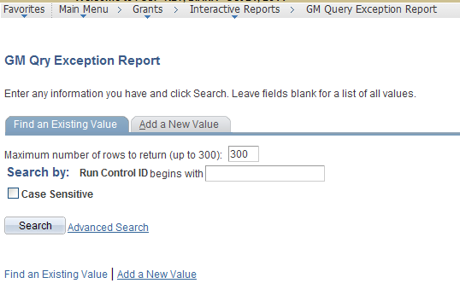

- Click for an existing Run Control ID.
- If none exists, click . A Run Control ID can have any name but can have no spaces.

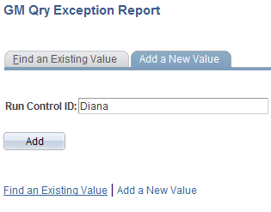
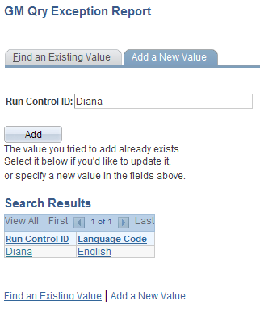

- Click the hyperlink on the Run Control ID you just created (or an existing one) to open the Run Control page.

This is the Run Control page:

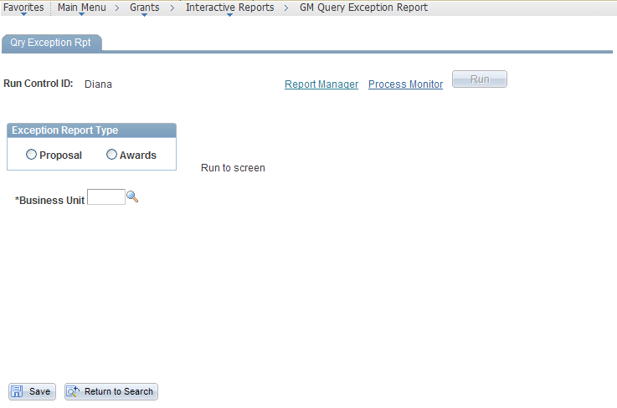

- OPTIONAL: To add this page to your Favorites, click Add to Favorites under the Favorites menu.

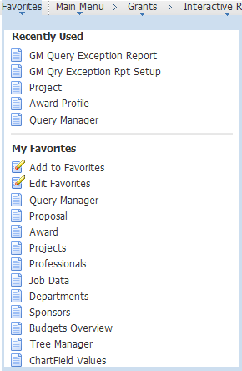

RUN TO SCREEN BACK TO TOP

- Click the Proposal radio button. Additional data entry fields will appear.
- Enter the Business Unit.
- Click , so the Business Unit will always be populated when you open this page.
- Enter the Proposal ID.
- Enter the Version ID. Make sure you tab out of the last field entered.

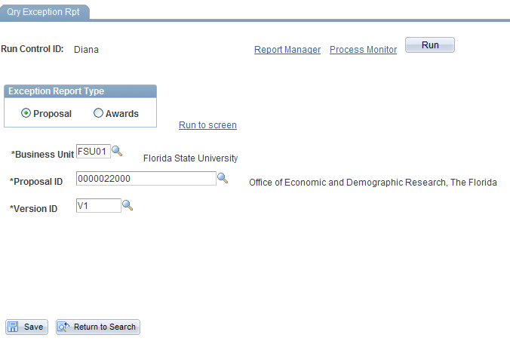
- Click the hyperlink 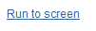

The program runs all of the exception queries related to the proposal and displays the errors that were found.

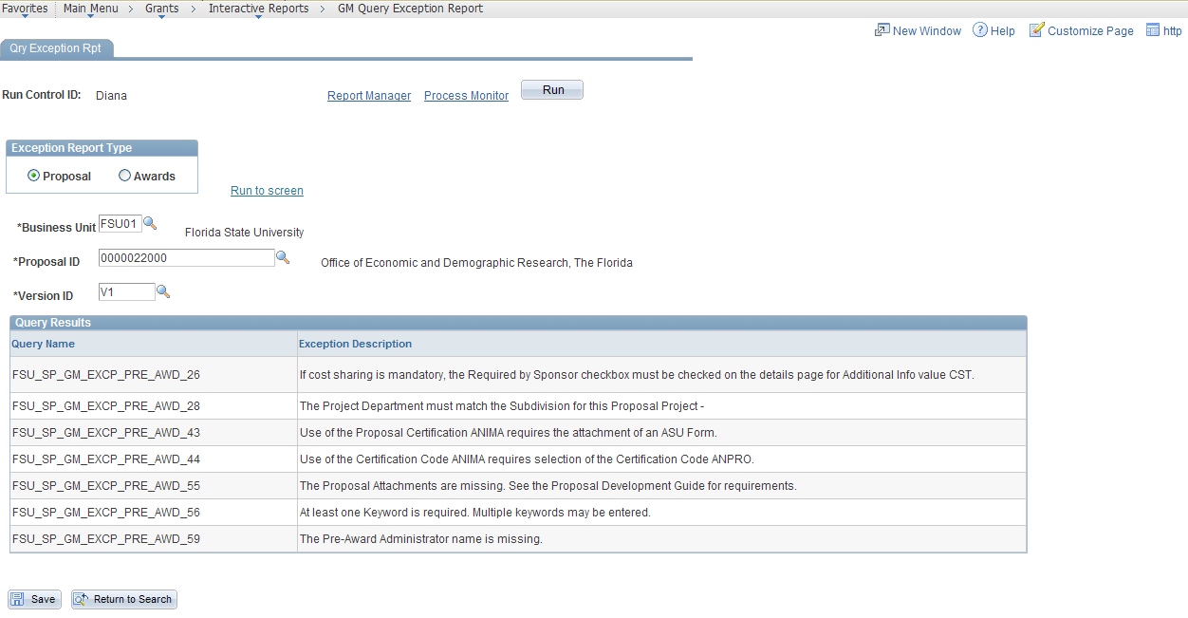

- Click

- Navigate to the proposal and correct each error. Please note that some of the exception queries are meant as warnings and may not indicate an error. For instance, the first query on this list states: “If cost sharing is mandatory, the “Required by Sponsor” checkbox must be checked on the details page for Additional Info value CST.” This message prompts the user to consider whether the box should be checked or not.

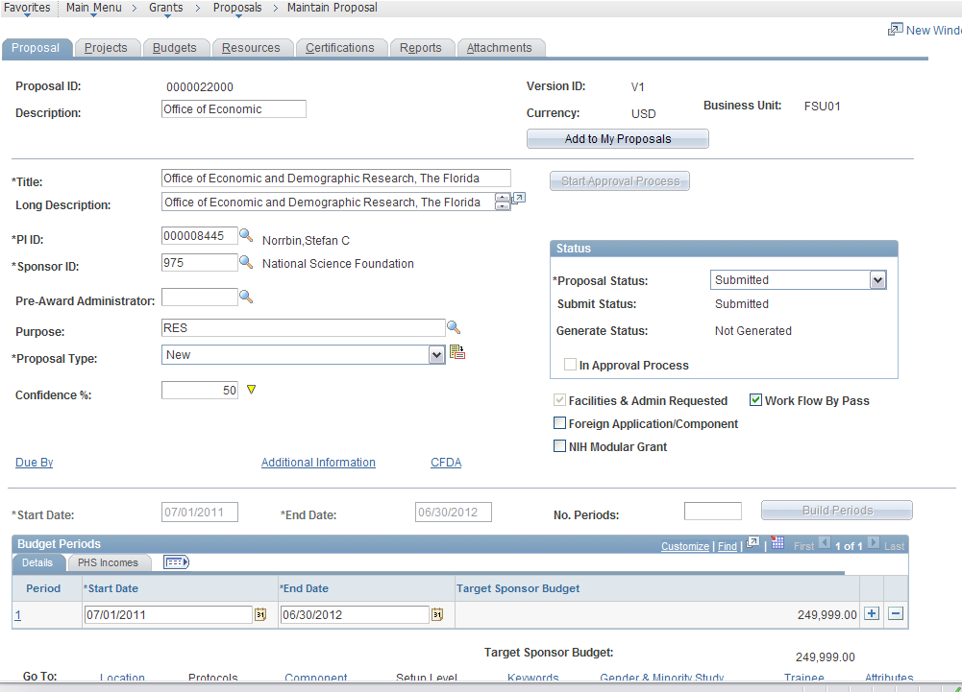

- Correct all errors.
- Click
- Return to the window for the exception report. If you use tabs, it might look like this:

Back on the Run Control page:

- Click the hyperlink

If all errors were corrected, you will see the message or you may see a warning message.

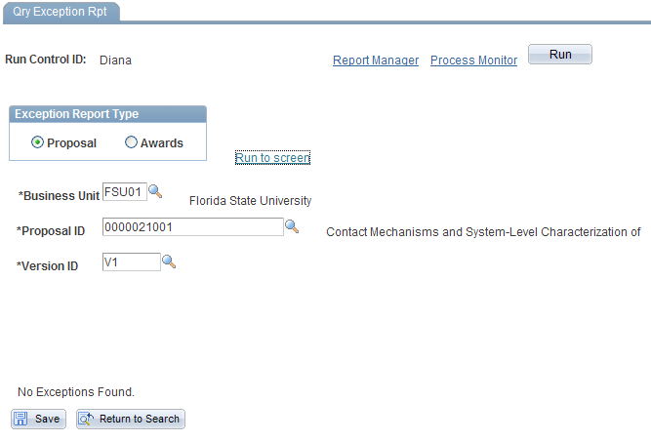

PRINT REPORT BACK TO TOP

- Enter proposal criteria.
- Click

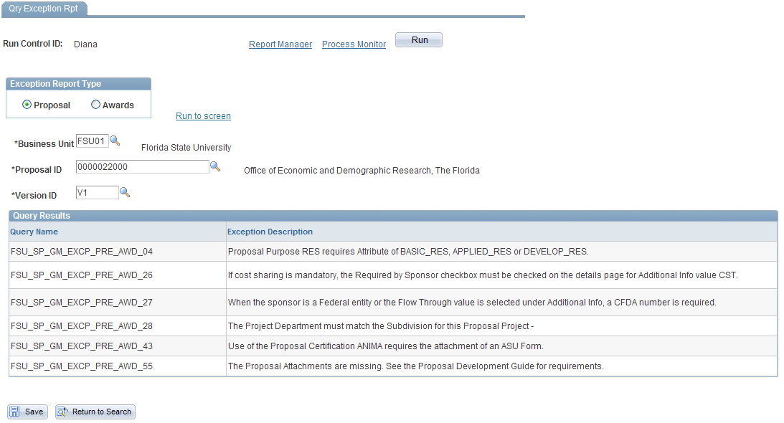

Do not change any of the default values on this page.

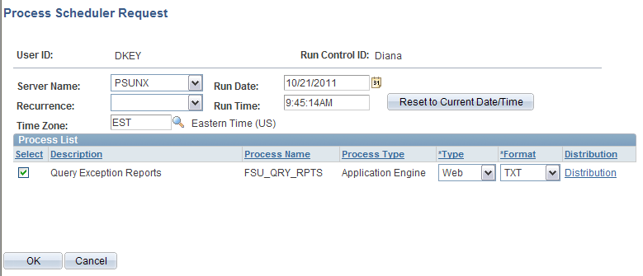

- Click

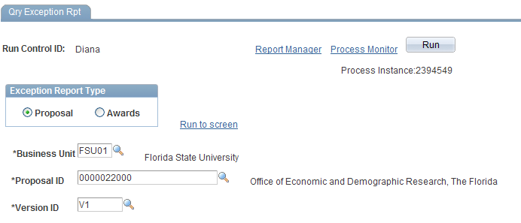

Click

The top row shows the program currently in queue to run.

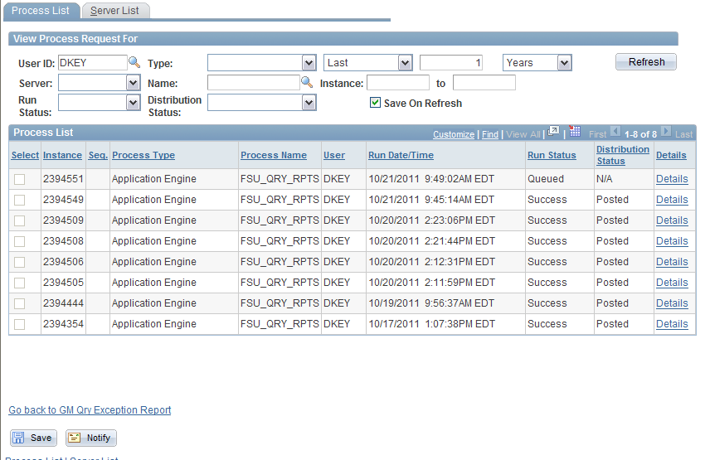

Wait for about 30 seconds then—
- Click

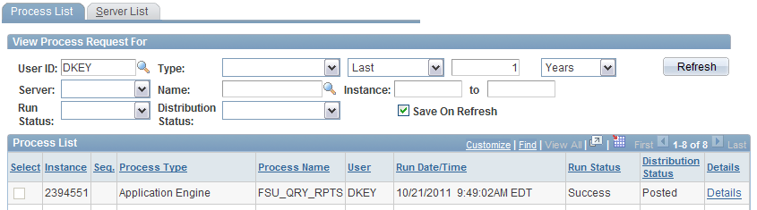

The top row must show “Success” under Run Status and “Posted” under Distribution Status.
- Click
- Click
- Click the file with the “.txt” extension (example: )

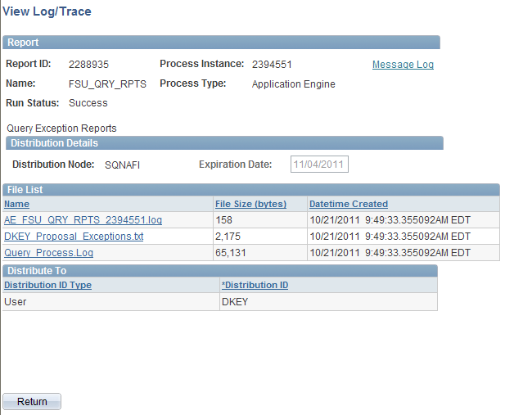
A new window will open with the Proposal Exception Report displayed like so:

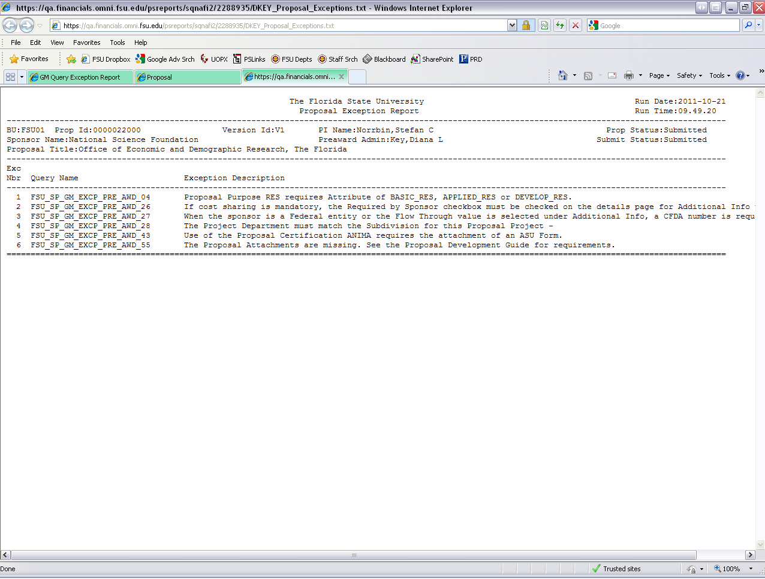

- Click the Print button on your browser to print the document directly to a printer, or select Print from the File menu to print to PDF.
- Go back to the Run Control window.
- Click
- Click
- Click

GET PROCESS INSTANCE NUMBER BACK TO TOP

- Enter proposal criteria.
- Click
- Click

The Process Instance Number will be displayed under the button.



