Queries in HR

ER_SPONSOR_CAPS_PROJ_LEVEL: Project Level Salary Caps
ER_SPONSOR_CAPS_SPNSR_LEVEL: Sponsor Level Salary Caps

HR Tables related to Salary Cap data:

ER_PROJECT_CAPS

1 | ER_PROJECT_CAPS | ER_PROJECT_CAPS | ER_PROJECT_ROLE | ER_PROJECT_ROLE
2 | ER_PROJECT_CAPS | ER_PROJECT_CAPS | ER_SALCAP_AMT | ER_SALCAP_AMT
3 | ER_PROJECT_CAPS | ER_PROJECT_CAPS | LASTUPDDTTM | LASTUPDDTTM

ER_PROJECT_1

 | PAGE | RECORD | FIELD | FIELD
4 | ER_PROJECT_1 | ER_PROJECTS | ER_DEFAULT | ER_DEFAULT
5 | ER_PROJECT_1 | ER_WRK | ER_DEFAULT | ER_DEFAULT
6 | ER_PROJECT_1 | ER_PROJ_RPTS | ER_DEFAULT | ER_DEFAULT

FACET pages where Salary Cap info stored.

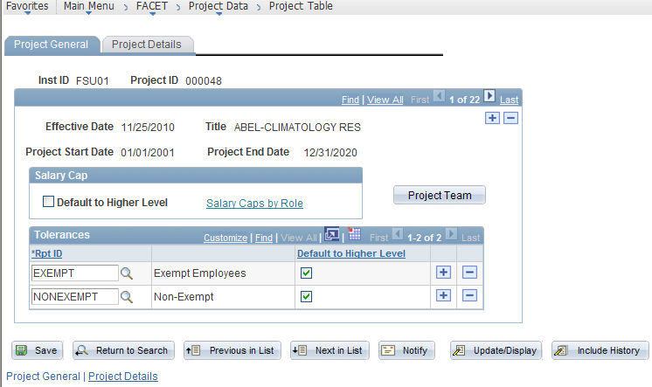

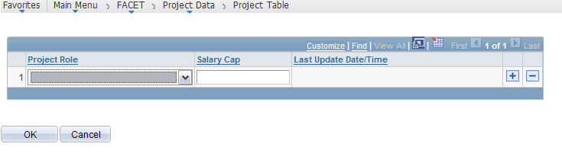
- If “Default to Higher Level” is checked, the cap configured on the Sponsor page is used for the Project.
- If it is not checked, the Salary Cap can be configured on a project-by-project basis, overriding the cap configured on the Sponsor page.

