RAMP Upgrade Highlights

Welcome to the latest RAMP upgrade. The following information briefly summarizes the new features and changes you will encounter as you continue using RAMP.
We have spent the last three months working with our vendor partner to seamlessly integrate this version of the software package and the FSU-specific customizations into our existing platform.
Please feel free to contact us if you have questions about the new functionalities or if there appears to be anything that is not functioning correctly. Contact us via email for RAMP General Support at RAMP@fsu.edu
Thank you for your patience as we continue to improve your RAMP user experience.

Highlights by Module
AGREEMENTS
What's New?
Mass Personnel Updates
Mass Update activities can update administrative assignments on multiple projects in a single run. This is much more efficient than past methods that allowed update to only one project at a time.
- May be requested from RAMP-Agreements@fsu.edu by the department for Agreements that are not in an editable state.
- Mass updates may be performed to replace an owner, replace a primary contact, and/or add or remove collaborators.
Administrative Editor(s)
Each agreement identifies a responsible department. Administrative editors will be identified for each responsible department who will have view/edit access to all agreements assigned to that responsible department. Only limited staff will have this access. The Office of the Vice President for Research with work with school and department leadership to identify who will be assigned this role.

- Will be able to view all agreements assigned to that department.
- Will have access to edit all agreements assigned to department, plus the amendments to those agreements. They have edit permissions in the same states in which the PI, primary contact, and collaborators do—Pre-Submission, Unassigned, and Clarification Requested. An audit log of all edits made is maintained in RAMP.
- Have access to the Copy Agreement and Manage Relationships activities. It is recommended that same Administrative Editors be assigned to Grants so that they will have access to the related Funding Proposals and Awards.
- Can use the Manage Access activity, which allows them to assign themselves as the primary contact or a collaborator, which in turn lets them execute additional activities.
- Are not visible on the agreement's SmartForm, but they appear on the Contacts tab in the agreement workspace.
- Do not see agreements in My Inbox or receive notifications (unless they have another association with the agreement, such as being assigned as the primary contact).

What's Changing?
Primary Contact (Agreement Creator role repurposed)

- Will see the Agreement in My Inbox whenever the PI sees the Agreement in My Inbox (i.e., during the Pre-Submission and Clarification Requested states).
- Can create amendments for the Agreement.

Created By (i.e., user who clicked the Create Agreement button)

- Will lose access to the Agreement beyond the Pre-Submission state (unless assigned to a role such as PI, Primary Contact, or Collaborator).
- Will see the Agreement in My Inbox during the Pre-Submission state only (unless assigned to a role as noted above).
- Cannot create amendments for the Agreement (unless assigned to a role as noted above).

Manage Access activity replaces Manage Agreement Personnel and allows Primary Contact and Collaborator assignments to be made directly on the parent Agreement and in any workflow state.

- Can be used for reassignment of Primary Contact and Agreement Collaborators
- Can be executed on the parent Agreement only, in any state by the following users:
- Office Staff
- PI/Manager
- Primary Contact
- Collaborators
- Organization-based Administrative Editors

Responsible Department field has moved from the Agreement Upload page to the General Agreement Information page. Responsible Department also displays in the Workspace.

Contracting Party label replaces Select an Organization on the General Information SmartForm page.

Manager/PI caption replaces Agreement Manager on the Workspace.

The title on the Communication tab on the Workspace is now Correspondence.

Reviewer First Name and Reviewer Last Name are replaced with Owner (First) and Owner (Last) on the All Agreements tab. Reviewer replaced with Owner (First) and Owner (Last) on the New, In Progress, Active, Evergreen, and Archived tabs.

Amendment Changes:
- Primary Contact and Collaborators have been removed from amendment SmartForms.
- Primary Contact and Collaborator changes made via Manage Access are immediately synced from the parent agreement to all the child amendments.
  - This ensures that the agreement's Primary Contact and Collaborators have permission to access the child amendments, including the ability to execute activities and receive notifications for amendments, and to see amendments in My Inbox.
  - The Contacts tab on the workspace of an amendment reflects values for Primary Contact, Collaborators and Administrative Editors that always match the values of the parent agreement.

EXPORT CONTROL

No Change

GRANTS
What's New?
Mass Personnel Updates:
Mass Update activities can update administrative assignments on multiple projects in a single run. This is much more efficient than past methods that allowed update to only one project at a time.
- May be requested from RAMP-Grants@fsu.edu by the department for Funding Proposals and Awards that are not in an editable state.
- Mass updates may be performed to assign an Administrative Contact, and/or to manage Team Members who have Edit or Read-Only rights.
Administrative Editor:
Each grant identifies a responsible department. A set of administrative editors may be identified for each responsible department who can view and edit all grants assigned to that responsible department. School leadership will identify who has this role.
- Automatically get view and edit access to all proposals and awards that are associated with the responsible department. Budgets give access to the same editors set as the parent proposal. Likewise, award modifications, award modification requests, and subawards give access to the same editors set as the parent award.
- Must be assigned directly to the responsible department associated with the Funding Proposal/Award.
- Have edit permissions to the SmartForm in the same states the PI does.
- Have access to the Manage Tags, Add Attachments (Funding Proposals only), Copy (Funding Proposals only), Send Email, Manage Access, and Add/Log Comment activities. They can use the Manage Access activity to assign themselves as the administrative contact, which in turn lets them execute additional activities.
- Are not visible on the project SmartForm, but they appear on the Reviewers tab in the project workspace.
- Do not see the associated projects in My Inbox or receive notifications (unless they have another association with the project, such as being assigned as the Administrative Contact).

Effort Metric:
- The Default Effort Metric is set to Months. Funding Proposals created after the upgrade will display personnel effort in the proposal budget in Months.
- New Effort Metric question allows users to toggle the Effort Metric between Months and Percentage on a particular Funding Proposal. This allows the personnel effort to be entered as either Months or Percentage on a particular Funding Proposal budget.
Funding Proposal Budgets:
- A Duration row has been added to the Budget Period row headers
- New display on Personnel Cost page where users will use the Edit button to enter the months/percentage effort and salary being requested. The Show Effort button toggles between Show Effort and Show Totals displays.
- New Monthly Salary Cap field only displays an amount when a salary cap has been applied.
- New Monthly Rate field appears in the Show Effort display. The value of monthly rate is the annualized salary divided by 12. The system now displays an annualized salary for all employees.
PI Certify Activity:
- The Certify activity is only available to the PI.
- Allows PI to certify the Funding Proposal in multiple workflow states before it reaches the Pending Sponsor Review state. (It is recommended that PI Certify prior to submitting Funding Proposal for Department Review.)
- When certification status = No, the Funding Proposal appears in My Inbox for the PI and Administrative Contact.
- If Funding Proposal is submitted to department review and certification status = No, a notification is sent to the PI and the Administrative Contact.
- Once the Certify activity is executed, the activity is permanently hidden.
- All proposals will be required to be certified by the PI before being submitted to the funding agency.
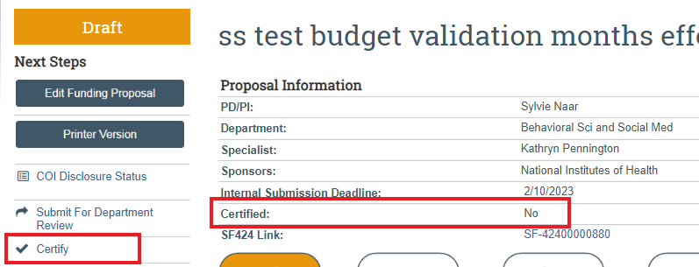
Export Control and Foreign Activity Monitoring:
- Three new required questions have been added to the Compliance Review SmartForm page.
- When a project involves research-related foreign activity, user selects applicable countries and provides optional explanation of activity details.
- For proposals, the selected countries and optional explanation map to the SF424.
- These questions will now also have to be answered for existing awards when an award modification includes the Compliance Review page.
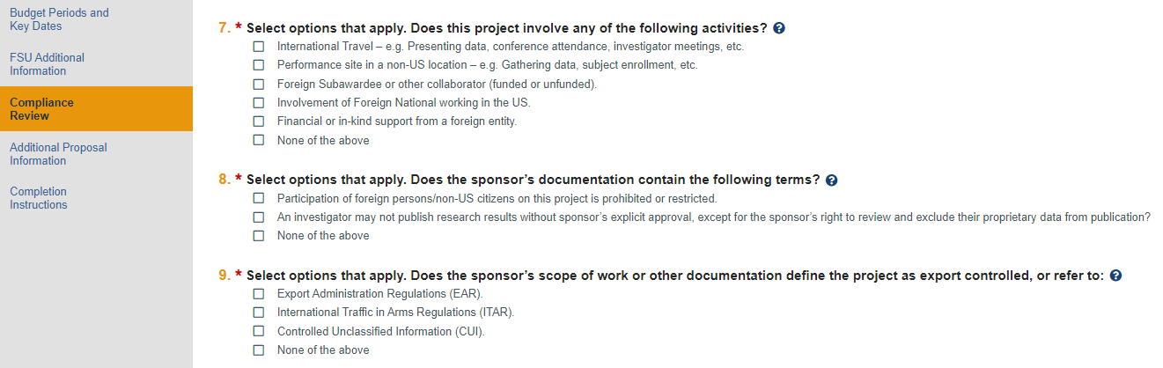

What's Changing?
Submit for Department Review:
Certification statements and checkboxes have been removed.
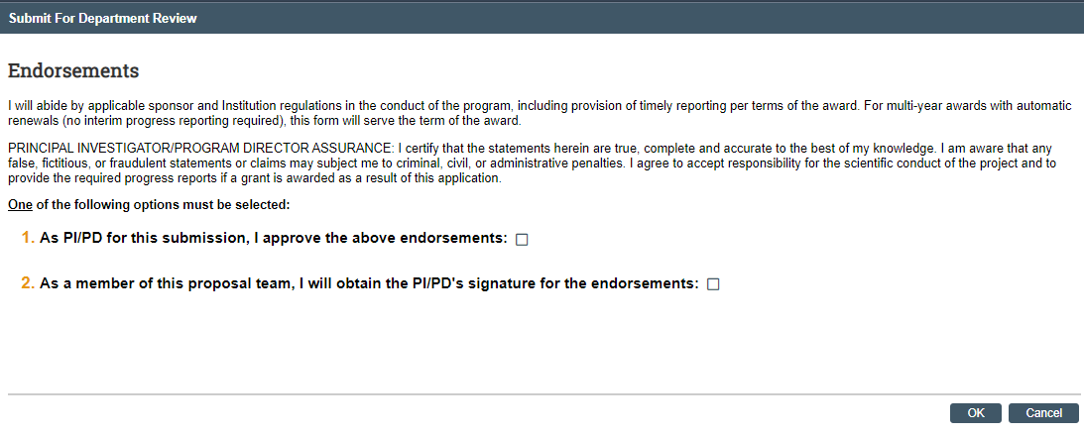

New display contains a field for Comments and Supporting Documents.
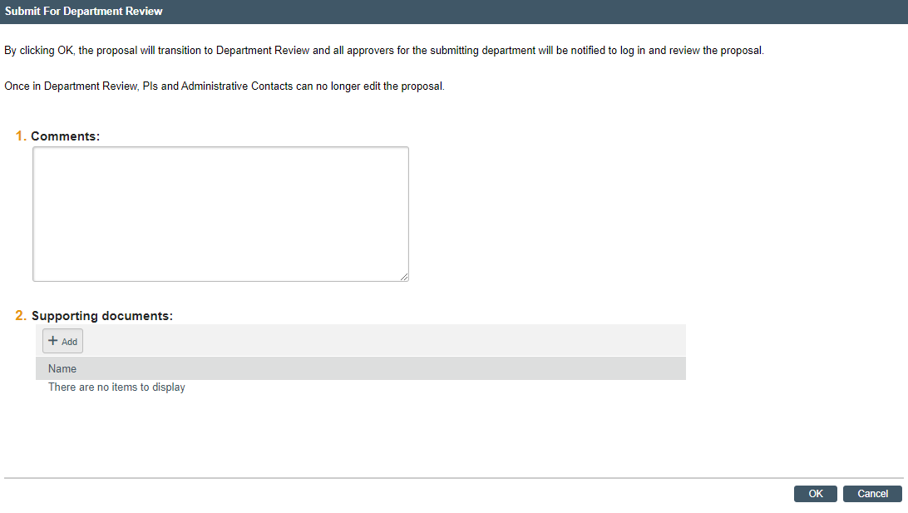
Labeling:
- Column header Primary Sponsor under the Proposal tabs has been changed to Direct Sponsor.
- Manage Guest List activity has been replaced with Manage Access activity.
- Organization label changed to Subrecipient for question No. 2 on the Subaward Budget Information SmartForm page.
Budget:
- Personnel Costs Definition and Personnel Costs in the proposal budget now display Annualized Salary instead of annual salary.
- On the General Budget Information SmartForm page, question No. 6, "Apply inflation rate to personnel costs?" has been removed. The cost row for each personnel cost on the budget is marked to have inflation applied by default. The user can still control the personnel inflation on the Personnel Cost Definition SmartForm page.
- Inactive users will not be displayed among the available options for adding personnel costs.
- Budget now maps up to 10 lines of other direct costs to the SF424 RR budget form Section F – Other direct costs.
- The Make a Copy activity will only be available to users who can edit the budget in editable states.
SF424:
- Funding Opportunity Announcements will now display required forms when there are optional unsupported forms.
- The Update SF424 Research Plan activity will not map a document to the SF424 which cannot be deleted on the SF424 PHS 398 Research Plan SmartForm page.

Awards:
- PI and Administrative Contact no longer auto-populate in the list of Team Members with Edit Rights, because as PI and Administrative Contact, they already have edit rights.

IACUC
What's New?
Pre-Submission Assistance state
PI/Protocol Team Member may use this activity to request assistance from IACUC staff or veterinarians with specific aspects of the submission before submitting for review. Performing this activity moves the protocol to the Pre-Submission Assistance state and places the request in the IACUC Coordinator's inbox. The PI/Protocol Team Member may make edits to submissions while in the Pre-Submission Assistance state.
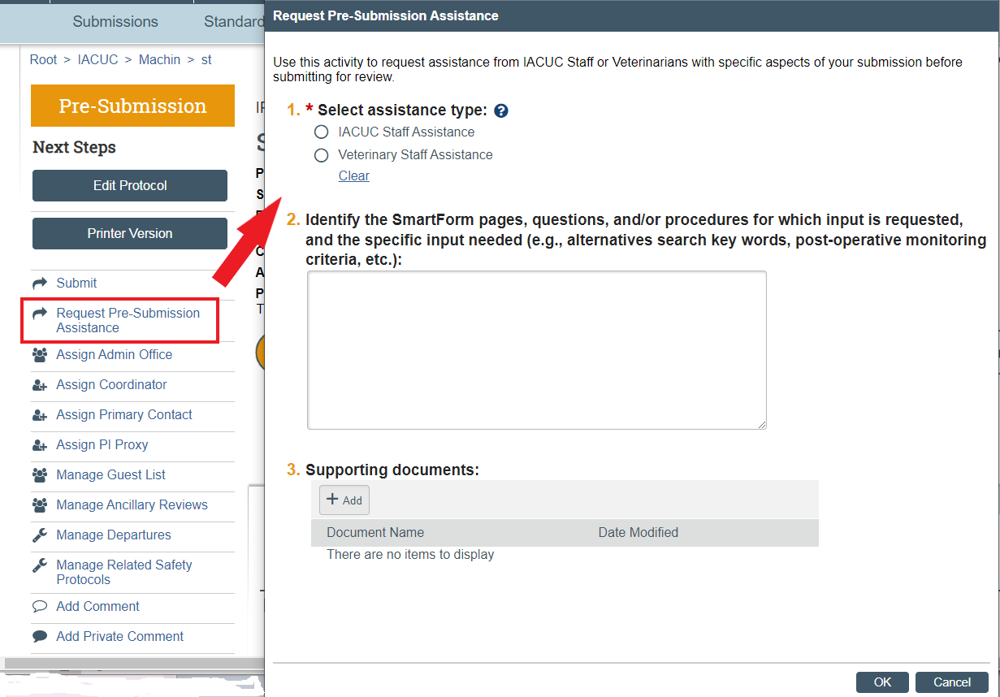

Request New Personnel While Another Amendment is Under Review
PI/IACUC staff can use the Request Personnel activity to request new personnel to work on a protocol while an amendment is in process. This activity is available on the amendment workspace in the Pre-Review and IACUC Review state. This activity can be used even if the amendment is under IACUC review for other changes.
After the initial request is made, IACUC staff are notified, and they can review the details and authorize new personnel. If IACUC staff notify the requestor about any missing training or other requirements, the requestor can use this activity to update personnel information.
To request new personnel
- From the submission page, click the desired amendment.
- Click Request Personnel Update.
- Click Add.
- Select new protocol team member(s), permissions, role, and procedure(s) they can perform.
- Click OK.
- Enter comments and attach supporting documents, if required.
- Click OK. The request is sent to IACUC staff for review.

What's Changing?
Experiments
On the Add Experiments SmartForm page, question No. 6 has been changed from "Select common procedures" to "Select procedures." Question No. 7, "Define variable procedures," has been changed to "Describe any variations to the selected standard procedures."
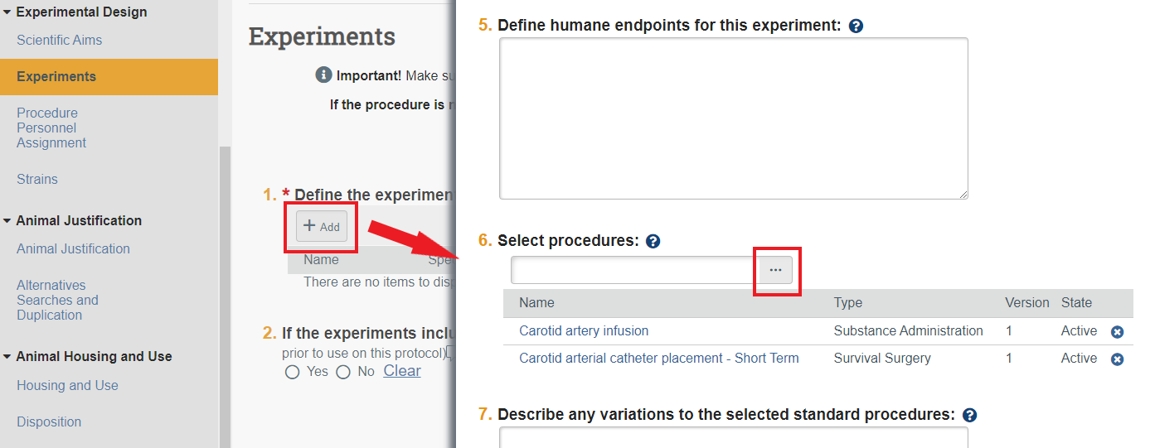

In the IACUC submission SmartForm, on the Experiments view, it now displays Procedures and no longer displays Common Procedures, Variable Procedures, and Variable Description.
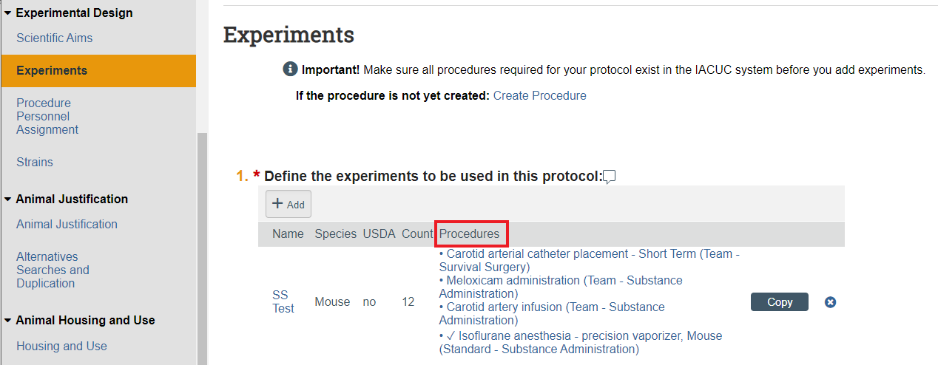

IRB
What's New?
Drug Type
A new required question, Specify the type (e.g., combination products, biologics, etc.) has been added to the Add Drug slide-in SmartForm page. As a required question, PIs will have to answer this question for existing studies, when completing Other Parts of the Study modification.
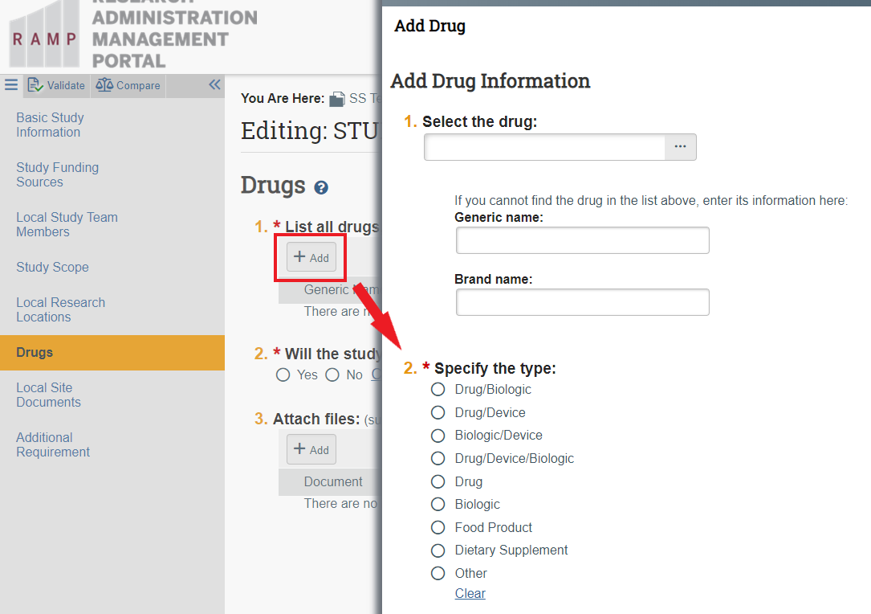

Some selected RNI Improvements
- The Manage Ancillary Reviews activity has been added to all RNI states except Discarded, allowing selected users to input review comments.
- A workflow stoppage has been added for outstanding required ancillary reviews.
- Users added as ancillary reviewers will have read access.
- Ancillary Reviewers tab is included on the workspace.
- The Submit RNI activity includes notifications to ancillary reviewers.
- New Manage Editors Activity available to the IRB Coordinator, IRB Director, and RNI Creator in all states allowing selected users to edit RNI submissions after which the RNI will be read-only.

What's Changing?
PI Proxy Consistency
The PI Proxy now has the ability to Report Continuing Review Data on sites and external studies.

Need Assistance?

For answers to your upgrade questions specific to your RAMP module, email one of our experts at the RAMP Help Desk.

RAMP General Support: RSCH-RAMP@fsu.edu
RAMP Agreements: RSCH-RAMP-Agreements@fsu.edu
RAMP Export Control: RSCH-RAMP-ExportControls@fsu.edu
RAMP Grants: RSCH-RAMP-Grants@fsu.edu
RAMP IACUC: RSCH-RAMP-ACUC@fsu.edu
RAMP IRB: RSCH-RAMP-IRB@fsu.edu

